|  |  |  |  |  |  |
| --- | --- | --- | --- | --- | --- |
| Date | November 29, 2022 | | | Tester Name | Shahabuddin Syed |
| Environment | Penfax - Test | | | Login used |  |
| Operating System | Windows | Version: | Update: | | |
| Software Used | Edge | Version: | Update: | | |
| Select Software | Version: | Update: | | |
| Release version | 22.4.1 | | | | |
| Title | E22.02 | | | | |
| Test Type | Regression | | | | |
| Test Scenario | SPAF Quote from member in VPB  Scenario 1: Joint VPB member with current date used for retirement date  Scenario 2: Single VPB member with future date used for retirement date | | | | |
|  |  | | | | |
| Expected Results | That the quote will process, the balance or estimated amount on the quote is correct, that the joint annuity is hidden when member has no spouse.  Upon hitting the “quote” button that the letter appears in the communications tab. | | | | |
| Pass/Fail | Pass | | | JIRA# | N/A |

Find any active VPB member:

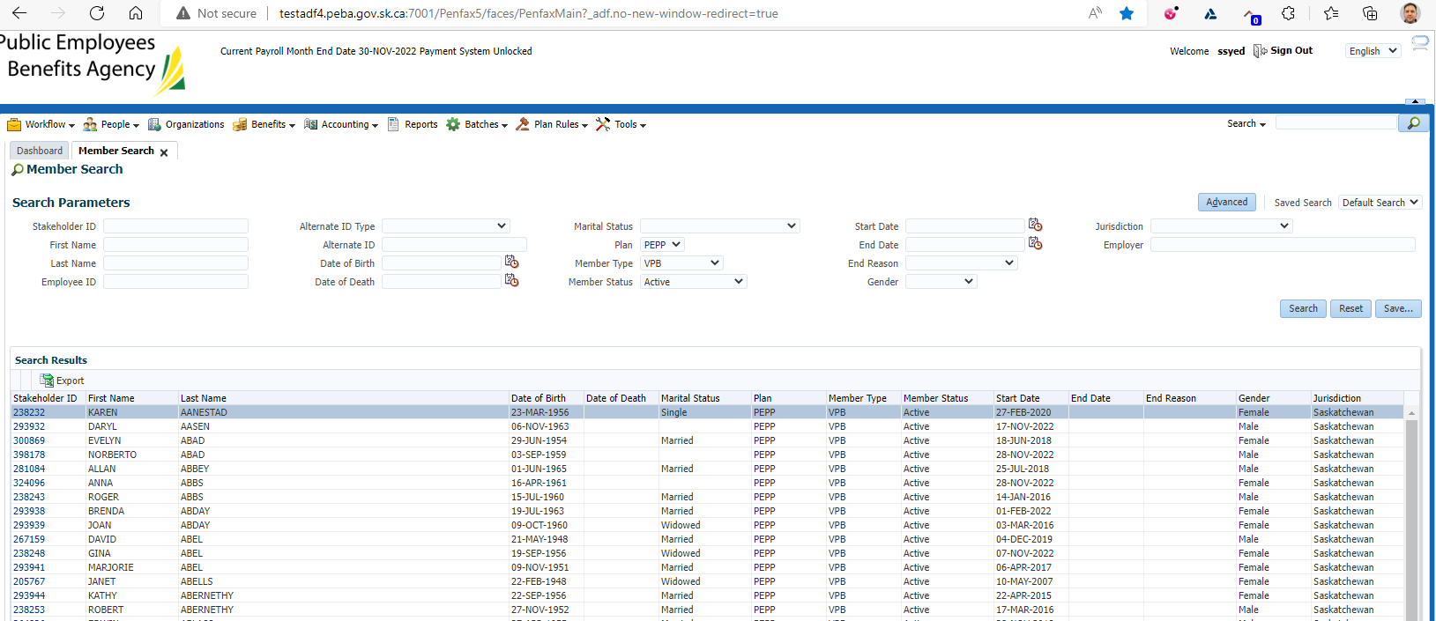

**Scenario 1: VPB member with spouse (and quote for current day)**

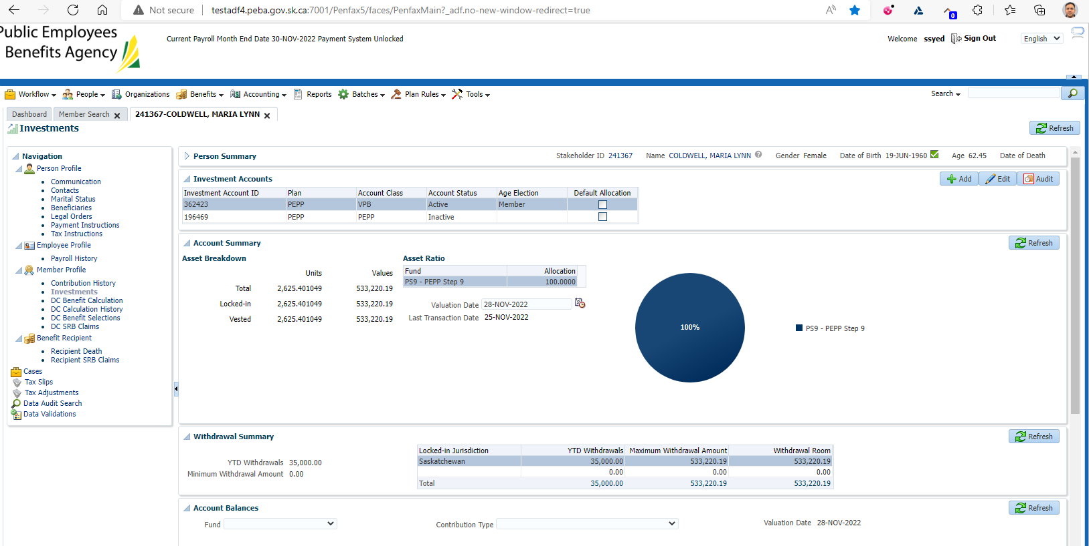

Process DC benefit calculation:

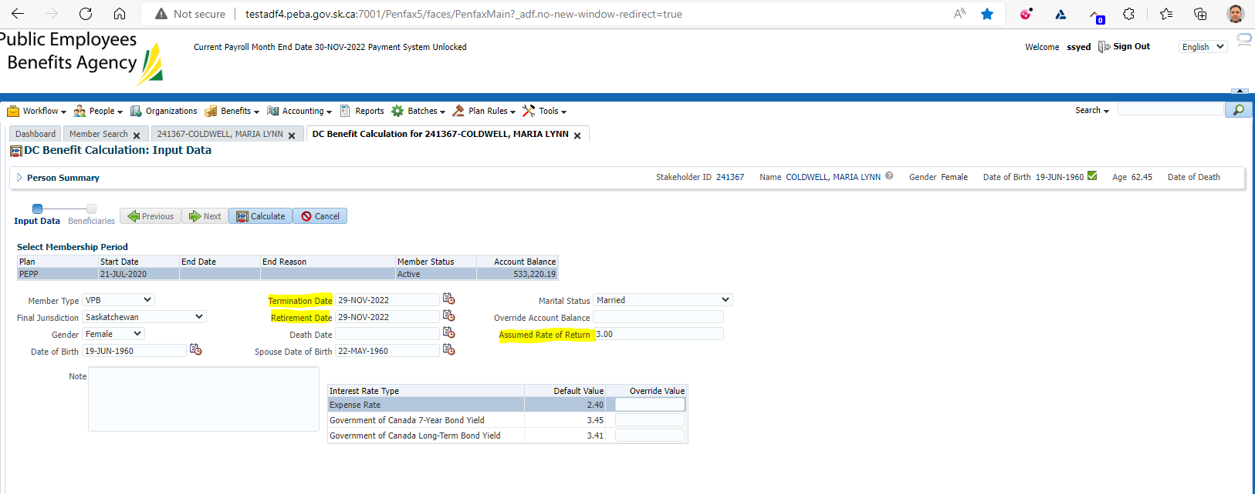

Enter in today’s date for termination & retirement date, and a rate of return & calculate:

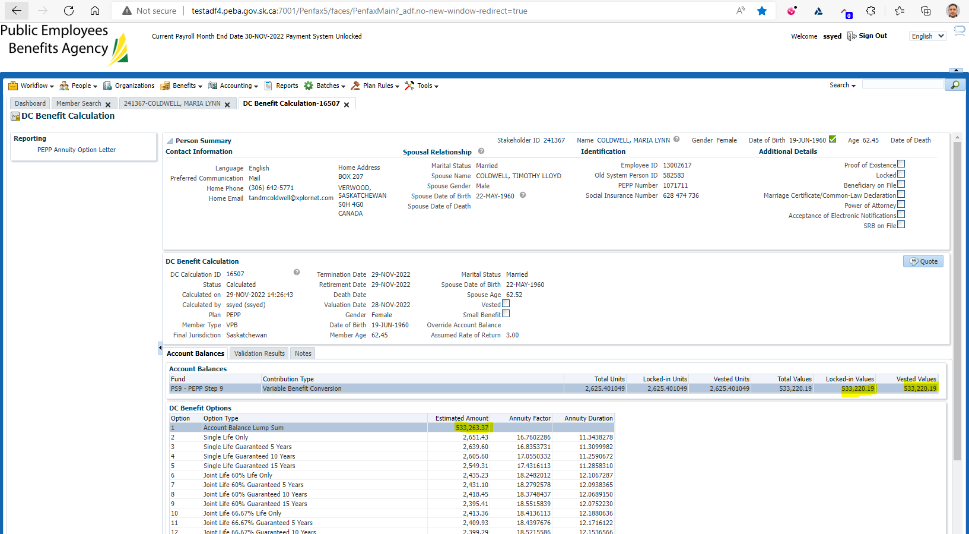

Confirm the balance used for the quote matches the current account balance

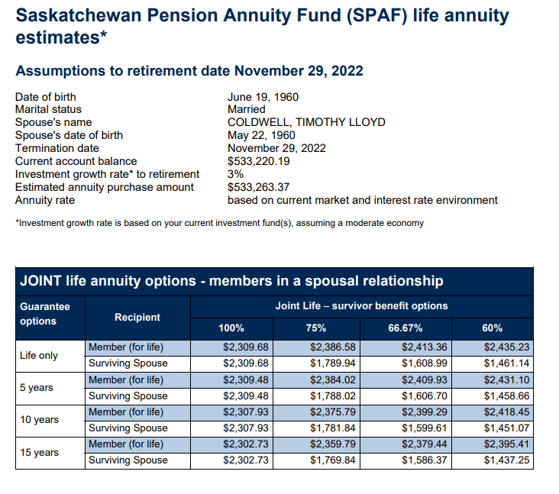

Confirm balances, dates and rate of return all generate on the letter

Confirm both single & joint annuity options (if spouse is on Penfax)

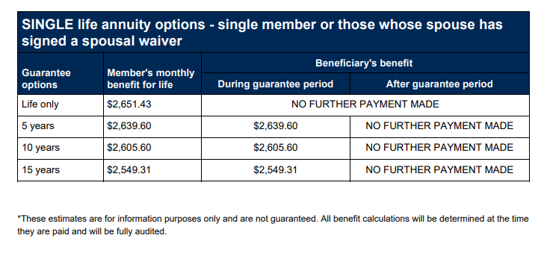

Press quote:

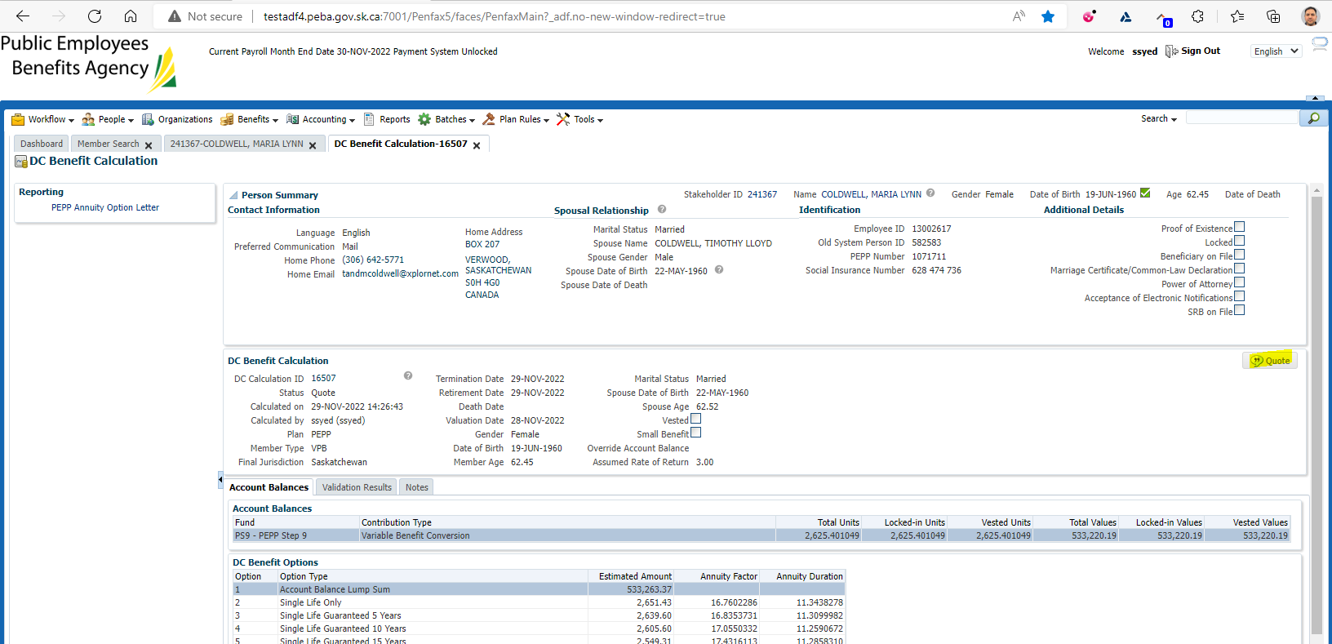

Confirm that letter shows instantly in communications tab:

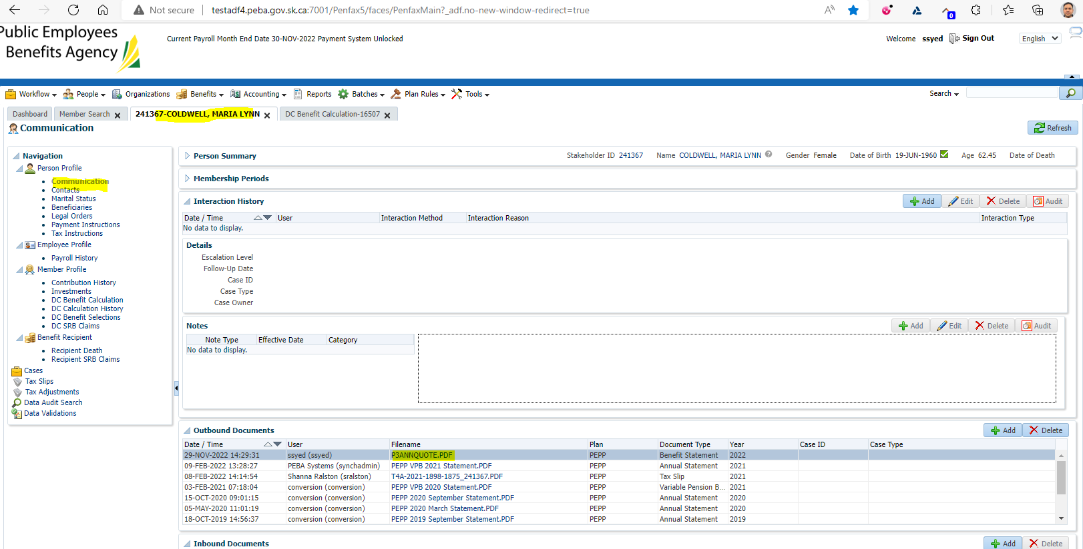

And is also saved under DC calculation history:

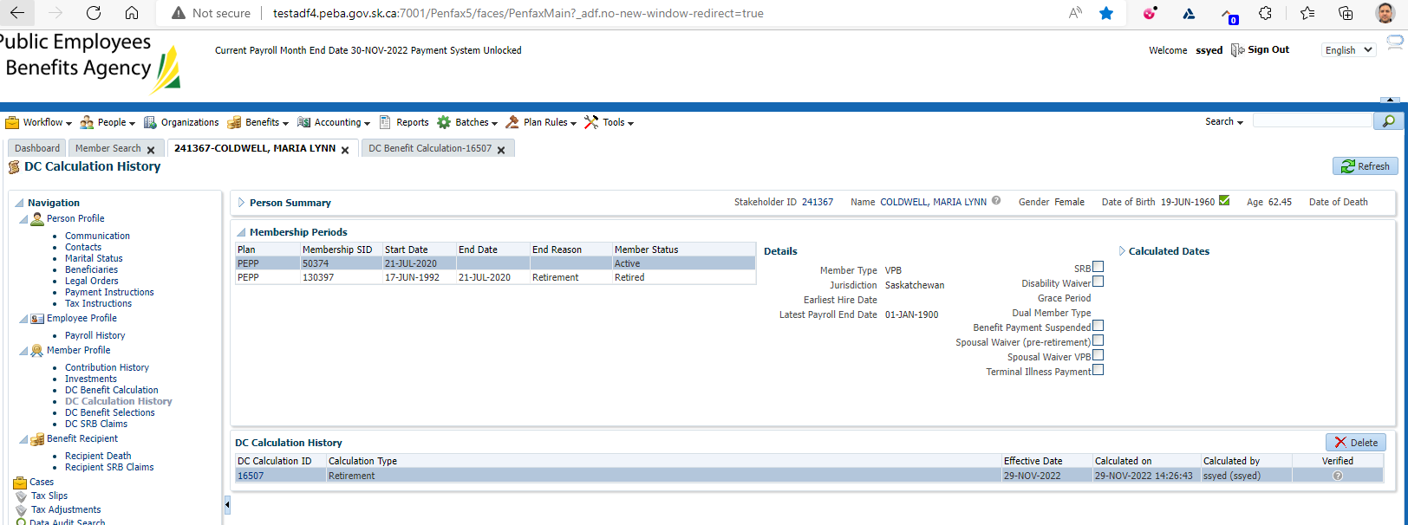

**Scenario #2: VPB member with no spouse (and in future)**

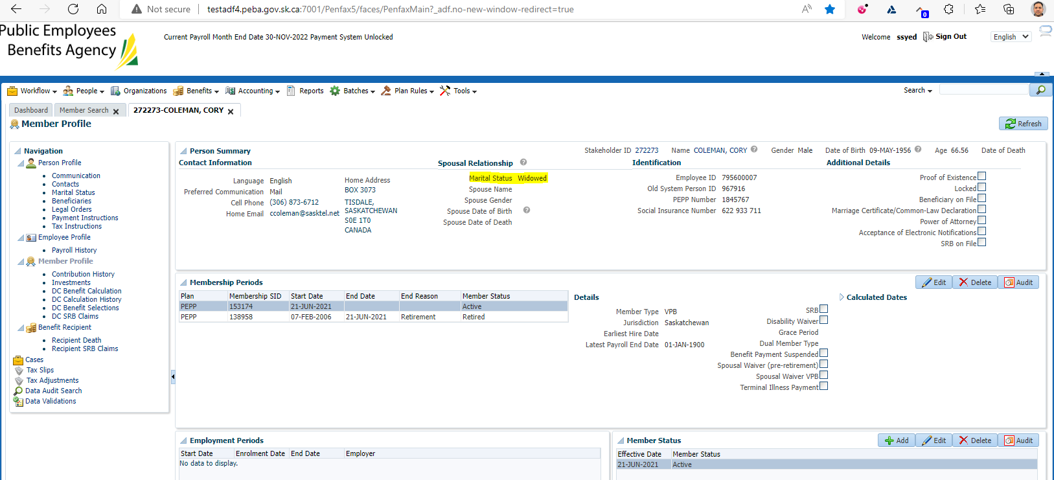

Clicked on DC benefit calculation & entered a future date for termination & retirement date, and entered a rate of return:

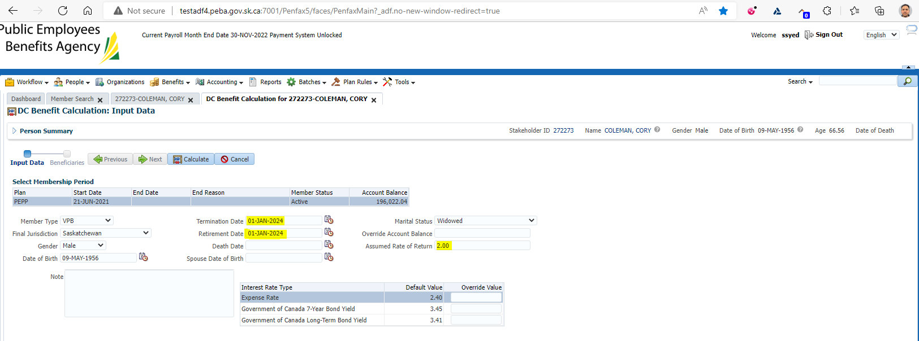

Clicked calculate:

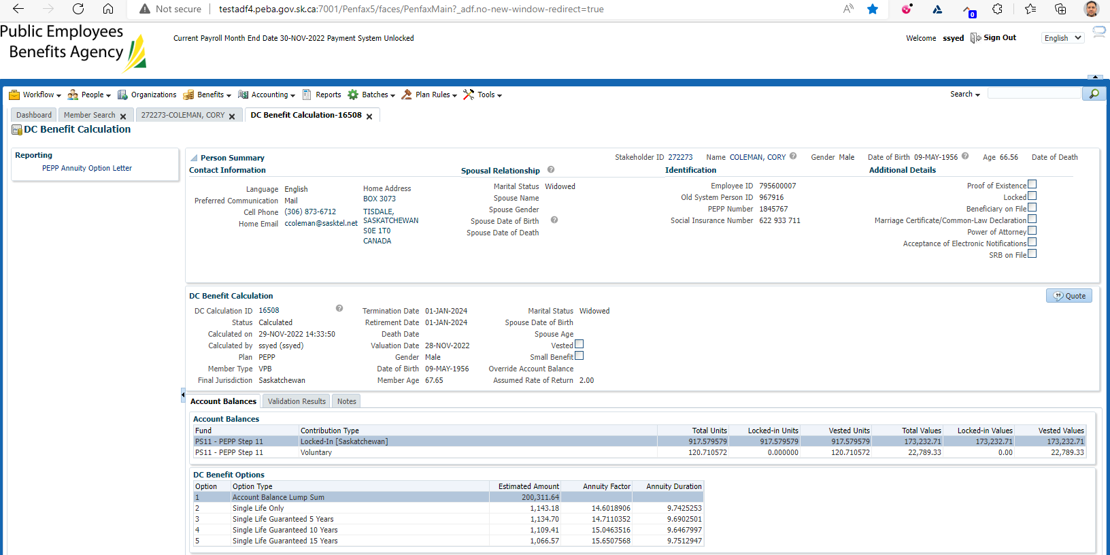

Confirmed that the joint annuity options are suppressed. Also confirmed that the estimated amount used in the quote differs from today’s account balance.

Confirming interest calculation on Penfax, open account balance projection calculator:

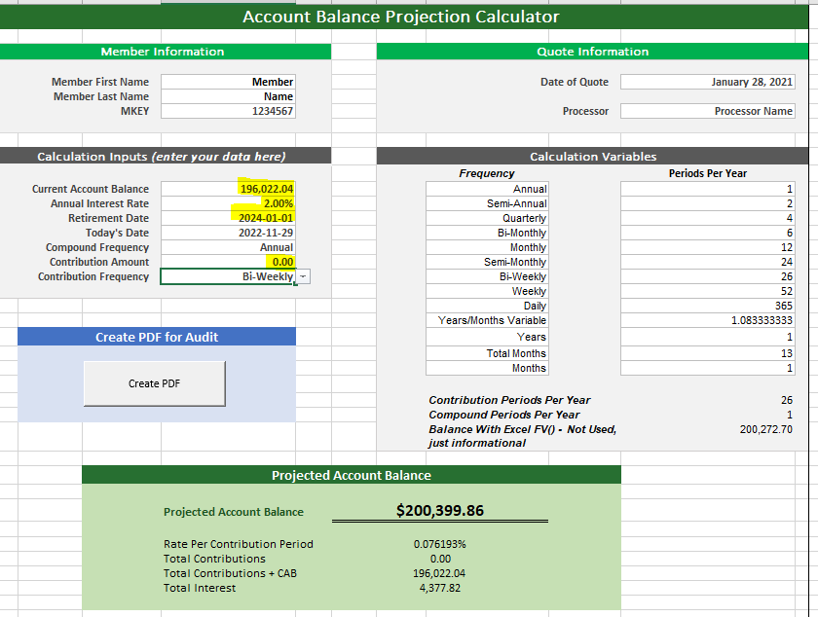

Entered in current account balance, interest rate that was keyed in to the DC benefit calculation, the retirement date that was keyed into the DC benefit calculation & ensured that the contribution amount was 0.00

Compared the projected account balance 200,399.86 with the estimated amount from Penfax of 200,311.64 – these amounts are similar and reasonable. The interest calculation from Penfax is slightly different than the calculator.

Confirmed that letter matches the information entered and Penfax:

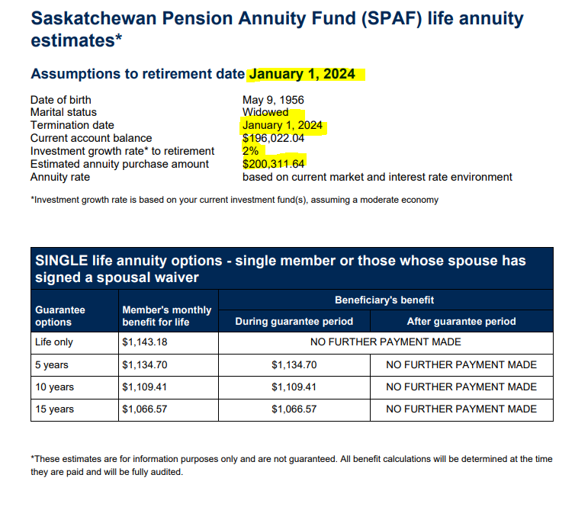

Letter saved in communications & shows in DC calc history.

